FOR IMMEDIATE RELEASE CONTACT: Amoree Brackins

www.akeep.org
www.facebook.com/akeep.org

Dr. Eric Mackey
The Chairman of
A-KEEP Executive Board
The Superintendent of
The Alabama State Depart. of Edu.

Honorable Gerald Dial
Cofounder
The Alabama State Senate

Executive Board of Directors

Mr. Lance Hunter
CEO, Hodges Warehouse+Logistics

Dr. Lance Tatum
Vice Chancellor of Troy University

Ms. Jeanne Charbonneau
Korean Family Coordinator of
The City of Montgomery

Dr. Chuck Ledbetter
Superintendent of
Pike Road Schools

Ms. Nichelle Nix
Director of Governor’s Office of Minority Affairs

Ms. Jennie Sim Cochren
Executive Dir. of Sims Investment

Dr. Suhyun Park Suh
Asso. Professor Emerita & Director Korea Center, Auburn University

Ms. Meesoon Han
Executive Director of A-KEEP

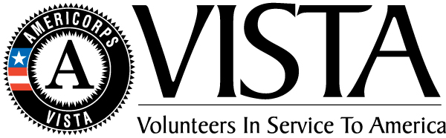

A-KEEP is an AmeriCorps Sponsor

General Contact:
Office Phone: (334) 625-8515
join@akeep.org

Physical Office:
RSA Union, Suite 732
100 North Union Street
Montgomery, AL 36104

Mailing Address:
C/O Alabama Commission on Higher Education
P.O. BOX 302000
Montgomery, AL
36130-2000
September 12, 2018 334-625-8515
amoree.brackins@akeep.org
MONTGOMERY NONPROFIT RECIEVES NSA STARTALK AWARD
MONTGOMERY, AL – September 21, 2018 - For the first time in the Southeast, a nonprofit organization was awarded the prestigious STARTALK grant in the Korean Category. With Korean language programs in New York and California, Montgomery’s own Alabama-Korea Education & Economic Partnership (AKEEP) is the 5th Korean language recipient to be recognized for the 11-year existence of the program.

The grant proposal was submitted to STARTALK by Meesoon Han, Executive Director of AKEEP, to operate a 15-day, non-residential summer program from July 16th - August 3rd, Monday – Friday titled AKEEP-TROY STARTALK: Cultural Treasure Hunters. Hosted by Troy University Montgomery, Cultural Treasure Hunters recruited 24 elementary and middle school students from Montgomery and Pike Road schools. The program aimed to deliver engaging and dynamic language learning experiences for students and creates a pathway for certification in critical need languages that are not commonly taught for teachers in the U.S.
“For some of the kids who haven’t been outside of Montgomery, STARTALK has been an eye-opening experience. By broadening their minds, we hope they’ve broadened their perspectives as well.”
- Mr. David Koda, Program Operations

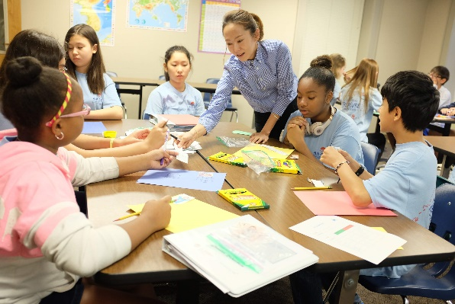
Cultural Treasure Hunters focused on making learning an adventure by allowing students to explore Korean language and culture in a learner-centered environment. Eligible special needs students were also welcome to participate as Special Education instructor, Mrs. Elisabeth Newell, facilitated alternative learning classes. Upon completion of the program students received graduation certificates and were recognized by Dr. Jim Purcell of the Alabama Commission on Higher Education and Dr. Jeffery Langham of the Alabama State Department of Education.
1Ms. Sara Park uses art to teach Korean language and culture

Due to the success of the Cultural Treasure Hunters program and incorporation of special needs learners, AKEEP has been selected to speak at the STARTALK Fall conference in Houston, TX.
-more-
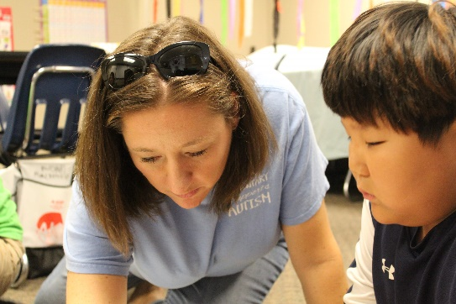
Mrs. Elisabeth Newell with special needs student, Seongmin Choi
About AKEEP
The Alabama-Korea Education and Economic Partnership (AKEEP) is a Montgomery, AL nonprofit acting as Global Partnership Facilitator for economic prosperity that provides education in global leadership and multicultural diversity. AKEEP’s works provide critical knowledge and services to improve the quality of life for students, professionals, and organizations while enabling these groups to take full advantage of the opportunities of growing economic ties between Alabama and South Korea. www.akeep.org

###

